Chapter 1: Introduction to Building AI Applications with Foundational Models

- There are two main types of language models: masked language models and autoregressive language models. They differ based on what information they can use to predict a token
  - Masked Language Model
    - A masked language model is trained to predict missing tokens anywhere in a sequence, using the context from both before and after the missing tokens.
    - In essence, a masked language model is trained to be able to fill in the blank.
    - Masked language models are commonly used for non-generative tasks such as sentiment analysis and text classification.
  - Autoregressive Language Model
    - An autoregressive language model is trained to predict the next token in a sequence, using only the preceding tokens.
    - Autoregressive models are the model of choice for text generation.
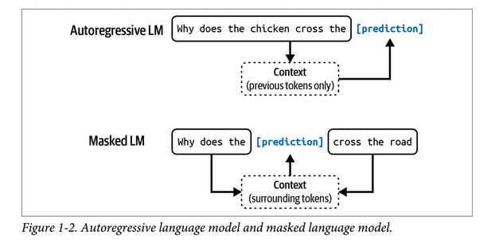

- Use case evaluation:
  - Different levels of risks, from high to low:
    - If you don’t do this, competitors with AI can make you obsolete.
    - If you don’t do this, you’ll miss opportunities to boost profits and productivity.
    - You’re unsure where AI will fit into your business yet, but you don’t want to be left behind.
- Setting expectations
- Milestone planning
  - Planning an AI product needs to account for its last mile challenge. Initial success with foundation models can be misleading. As the base capabilities of foundation models are impressive, it might not take much time to build a fun demo. However a good initial demo doesn’t promise a good end product.
  - The journey from 0 to 60 is easy. The journey from 60 to 100 is challenging.

- Three layers of the AI Stack
  - Application development: Providing a model with good prompts and necessary context.
  - Model development: Provides tooling for developing models, including frameworks for modeling, training, finetuning, and inference optimization. Because data is central to model development, this layer also contains dataset engineering. Model development also requires rigorous evaluation.
  - Infrastructure: Tooling for model serving, managing data and compute, and monitoring.
